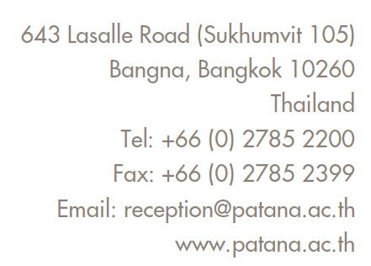

CONFIDENTIAL RECOMMENDATION FORM
nURSERY, fOUNDATION sTAGE 1 and 2 Applications

Note to Parents:
If your child currently attends a school or day care setting, please send this form to your child’s current teacher/key worker to complete. Please ask the teacher/key worker to send the completed form directly to Bangkok Patana School. This recommendation should not be shared with you or uploaded as part of your child’s online application.
In compliance with Bangkok Patana School’s PDPA Policy, our purpose of collecting the information in this form is to understand your child’s individual needs and assess the suitability of our programme and learning environment for them.
In asking your child’s current teacher/key worker to complete this form, you hereby authorise and give your consent for them to share all relevant information with Bangkok Patana School. This information will be treated as confidential.
Note to Teachers:
Please complete this recommendation form and send by email to admissions@patana.ac.th
This is a confidential form, and the feedback you provide will not be shared with parents.

STUDENT’S DETAILS
Student’s Name: |  | Date of Birth:
Current School: |  | Year Group/ Grade:
Date Enrolled: |  | Date Withdrawing:

TEACHER’S DETAILS
Teacher’s Name: |  | Teacher’s Job Title:
Teacher’s Email: |  | Date Completed:

Social, Emotional and Behavioural Aspects of Learning

Please estimate as best you can the student’s level of development in each of the areas below
compared to other children of the same age.
Mark “X” in the appropriate column.

 | Significant Difficulties | Below Average | Average | Above Average | Not Sure
Follows verbal instructions
Developmentally appropriate interactions with adults and children
Forms good relationships within class
Manages feelings and behaviour
Self-esteem
General focus and concentration
Handles changes to routine

 | Not at All | Rarely | Sometimes but within normal range | Cause for Concern | Not Sure
Appears anxious, nervous, sad, or tired
Gets angry or upset
Frequent sickness/ pains/ headaches
Seeks reassurance from other children or adults
Unsafe/ Dangerous Behaviour (please explain below)

Please comment on support from parents and home-school relationship:

Is the student receiving any additional support (at home or at school) for learning, social,  emotional or behavioural needs? If yes, please share details of support and strategies, attaching any individual education or learning plan below. | Y / N

Academic Aspects of Learning
Please estimate as best you can the student’s level in each of the areas below
compared to other children of the same age.
Mark “X” in the appropriate column.

 | Significant Difficulties | Below Average | Average | Above Average | Not Sure | Too Young to Estimate
Communication & Language
Clarity of speech
Vocabulary
Listening & attention
Understanding
Speaking skills
Physical Development
Overall gross-motor skills (physical coordination)
Overall fine-motor skills (hand-eye coordination)
Toileting and Self-Care

If your school follows the EYFS, please share the student’s Development Matters Stage(s)/ Early Learning Goals:

