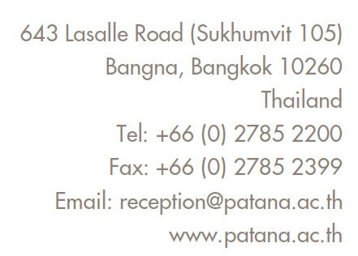

CONFIDENTIAL RECOMMENDATION FORM
year 1 to year 6 applications

Note to Parents:
Please ask your child’s current teacher to complete this form and send it directly to Bangkok Patana School together with a sample of your child’s independent writing. This recommendation should not be shared with you or uploaded as part of your child’s online application.
In compliance with Bangkok Patana School’s PDPA Policy, our purpose of collecting the information in this form is to understand your child’s individual needs and assess the suitability of our programme and learning environment for them.
In asking your child’s current teacher to complete this form, you hereby authorise and give your consent for them to share all relevant information with Bangkok Patana School. This information will be treated as confidential.
Note to Teachers:
Please complete this recommendation form and send by email together with a sample of the student’s independent writing to admissions@patana.ac.th
This is a confidential form, and the feedback you provide will not be shared with parents.
STUDENT’S DETAILS
Student’s Name: |  | Date of Birth:
Current School: |  | Year Group/ Grade:
Date Enrolled: |  | Date Withdrawing:

TEACHER’S DETAILS
Teacher’s Name: |  | Teacher’s Job Title:
Teacher’s Email: |  | Date Completed:

Independent writing sample attached (if student is not yet writing in English, please include a sample of writing in their home language)

Social, Emotional and Behavioural Aspects of Learning

Please estimate as best you can the student’s level of development in each of the areas below
compared to other children of the same age.
Mark “X” in the appropriate column.

 | Significant Difficulties | Below Average | Average | Above Average | Not Sure
Follows verbal instructions
Developmentally appropriate interactions with adults and children
Forms good relationships within class
Self-esteem
General focus and concentration
Handles changes to routine

 | Not at All | Rarely | Sometimes but within normal range | Cause for Concern | Not Sure
Appears anxious, sad, tired or unhappy
Gets angry or upset
Frequent sickness/ pains/ headaches
Seeks reassurance from other children or adults
Unsafe/ Dangerous Behaviour (please explain below)

Please comment on support from parents and home-school relationship:

Is the student receiving any additional support (at home or at school) for learning, social,  emotional or behavioural needs? If yes, please share details of support and strategies, attaching any individual education or learning plan below. | Y / N

Academic Aspects of Learning
Please estimate as best you can the student’s level in each of the areas below
compared to other children of the same age.
Mark “X” in the appropriate column.

 | Significant Difficulties | Below Average | Average | Above Average | Not Sure | Too Young to Estimate
Reading Skills
Phonics
Sight word knowledge
Reading comprehension- literal
Reading comprehension-inferential
Writing Skills
Handwriting- legibility
Spelling
Sentence construction
Writing organisation
Maths Skills
Mental Maths
Math procedures/ operations/ calculations on Paper
Reasoning/ problem solving
Oral Language Skills
Clarity of speech
Vocabulary
Listening skills
Physical Development
Overall gross-motor skills (physical coordination)
Overall fine-motor skills (hand-eye coordination)
Toileting and Self-Care
General Skills
Readiness to work in a group
Readiness to work with a partner
Readiness to work independently
Overall school attendance

Is the student receiving English Language Support (EAL/ESL Programme)? | Y / N

Additional Comments (if applicable):

