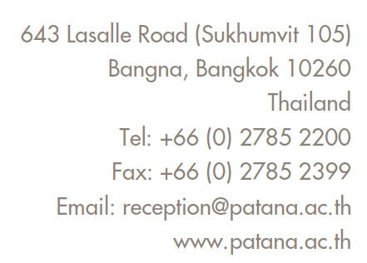

CONFIDENTIAL RECOMMENDATION FORM
Year 7 – Year 12 applications

Note to Parents:
Please ask your child’s current teacher to complete this form and send it directly to Bangkok Patana School together with a sample of your child’s independent writing. This recommendation should not be shared with you or uploaded as part of your child’s online application.
In compliance with Bangkok Patana School’s PDPA (Personal Data Protection Act) Policy, our purpose of collecting the information in this form is to understand your child’s individual needs and assess the suitability of our programme and learning environment for them.
In asking your child’s current teacher to complete this form, you hereby authorise and give your consent for them to share all relevant information with Bangkok Patana School. This information will be treated as confidential.
Note to Teachers:
Please complete this recommendation form and send by email together with a sample of the student’s independent writing to admissions@patana.ac.th
This is a confidential form, and the feedback you provide will not be shared with parents.
STUDENT’S DETAILS
Student’s Name: |  | Date of Birth:
Current School: |  | Year Group/ Grade:
Date Enrolled: |  | Date Withdrawing:

TEACHER’S DETAILS
Teacher’s Name: |  | Teacher’s Job Title:
Teacher’s Email: |  | Date Completed:

Independent writing sample attached (in English)

Student’s Academic Information
as per your school’s expectations
 | Working Towards | Working  At | Working  Above
Reading

Writing

Mathematics

Science

Work Ethic

Curiosity

Integrity

Approaches to Learning Competencies
as per your school’s expectations
 | Below Expectation | At  Expectation | Beyond Expectation
Thinking
Critical Thinking: Analysing and evaluating issues and ideas
Creative Thinking: Generating novel ideas and considering new perspectives
Transfer: Using skills and knowledge in multiple contexts
Communication
Reading, writing, and using language to gather information
Exchanging thoughts, messages, and information effectively through interaction
Social
Collaboration: Working with others effectively
Self-management
Organisation: Managing time and tasks
Affective: Managing their state of mind
Reflection: (Re)considering the process of learning
Research
Information Literacy: Finding, interpreting, judging, and creating information
Media Literacy: Interacting with media to use and create ideas and information

Has the student sat any standardised tests? If so, please attach results with this recommendation form. | Y / N

Is the student receiving English Language Support (EAL/ESL Programme)? | Y / N

Is the student receiving any additional support (at home or at school) for their learning? If yes, please share details of support and strategies below, and attach any individual education or learning plans. | Y / N

Is the student receiving any additional support (at home or at school) for social,  emotional or behavioural needs? If yes, please share details of support and strategies below. If you would like to discuss this further with a member of our pastoral team, please provide contact details. | Y / N

Please comment on support from parents and home-school relationship:

Additional Comments (if applicable):

