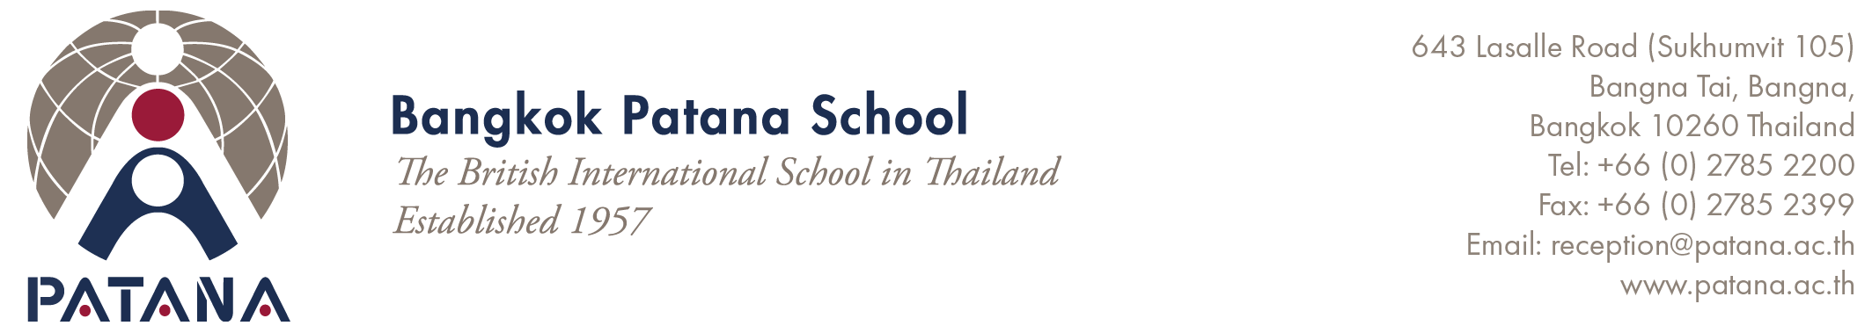
Bangkok Patana Student Safeguarding Code of Conduct for Parents, Legal guardian or Appointed guardian
Everyone at Bangkok Patana School has a shared responsibility to ensure the safety and protection of all students. We are committed to ensuring excellent safeguarding procedures in all areas of our school. To further support staff and student safeguarding, CCTV is in operation at all times on campus.
Please follow these expectations when you are on campus and share them with anyone who comes with you:
- Keep your Patana Card or Visitor tag visible.
- Using another person’s Patana Card or lending your card to others is strictly prohibited.
- Only use toilets and changing rooms with an adult sign on the door.
- Do not use cameras in toilets, changing rooms or areas where privacy is expected.
- Use good judgement and take photos only of your own child while on school premises. Do not share images of other students or other people online without their consent. Obey the guidance provided in school and report any concerns to a member of the Patana staff.
We pride ourselves on being a community-centred school with excellent relationships between parents, legal guardian or appointed guardian students and teachers. We have a shared responsibility to role-model the positive and respectful behaviours that we expect from our students. In particular, we cannot accept:
- Physical or verbal intimidation or harassment of staff, students and other parents, legal guardian or appointed guardian and others employees of the family on campus, at Patana events off-site, or when interacting with our Transport staff off-site.
- Any attempt to physically harm staff, students and others when on campus.
- Evidence of drug use or intoxication.
- Any form of discrimination such as racism, homophobia or sexism.
Unacceptable behaviours may result in a ban from the campus at all times or for a period of time, or police intervention.
Physical (corporal) punishment is illegal in Thailand and has a harmful impact on a child’s overall well-being. We do not condone the use of any physical punishment in the home and instead support families to use other proportionate and non-physical forms of discipline.

Employees of the family
As Parents, Legal guardian or Appointed Guardians it is your responsibility to ensure any family employees (such as nannies and drivers) are fully aware of the school’s safeguarding expectations, and that they comply with them when on the school campus.

Confidentiality between parents and school
We take student confidentiality very seriously. School staff will only share information about a child with their own parents or an agreed legal guardian and appointed guardian. In some circumstances, we may be required to share information with official authorities for reasons pertaining to the health and well-being of a child.
Likewise, we ask that parents legal guardian or appointed guardian do not breach confidentiality by sharing information about another family or student, except with Patana staff who have a direct professional role in relation to the student. This includes making comments about another family or student via social media or messaging platforms.

Bangkok Patana Student Safeguarding Code of Conduct for Parents, Legal guardian or Appointed guardian (Revised 21st Aug 2025) Page 1 / 2


Confidentiality between schools and appropriate agencies
BPS will ensure that personal data is shared in accordance with statutory obligations set out in the Thailand Personal Data Protection Act (PDPA). The school will ensure that safeguarding information is always shared lawfully for the purposes of keeping children safe from harm. Safeguarding records will only be shared with the receiving school’s Designated Safeguarding Lead unless it becomes necessary to discuss the records with appropriate Government agencies.

I have read and agree to follow this Bangkok Patana Student Safeguarding Code of Conduct for Parents, Legal guardian or Appointed guardian

Signature: ………………………………………… Print Name: …………………………………………….
Date: ……………………………………..……….. Parent/ Legal guardian/ Appointed guardian of: …………………………

Bangkok Patana Student Safeguarding Code of Conduct for Parents, Legal guardian or Appointed guardian (Revised 21st Aug 2025) Page 2 / 2

